**ADVANCED PROGRAMMING-II**

**ASSIGNMENT-1**

**Q1.** [**Print linked list**](https://www.geeksforgeeks.org/problems/print-linked-list-elements/0)**:**

**CODE:**

class Solution {

public:

void printList(Node* head) {

Node* curr = head;

while(curr!=nullptr){

cout<<curr->data<<" ";

curr=curr->next;

}

}

};

**Screenshot:**

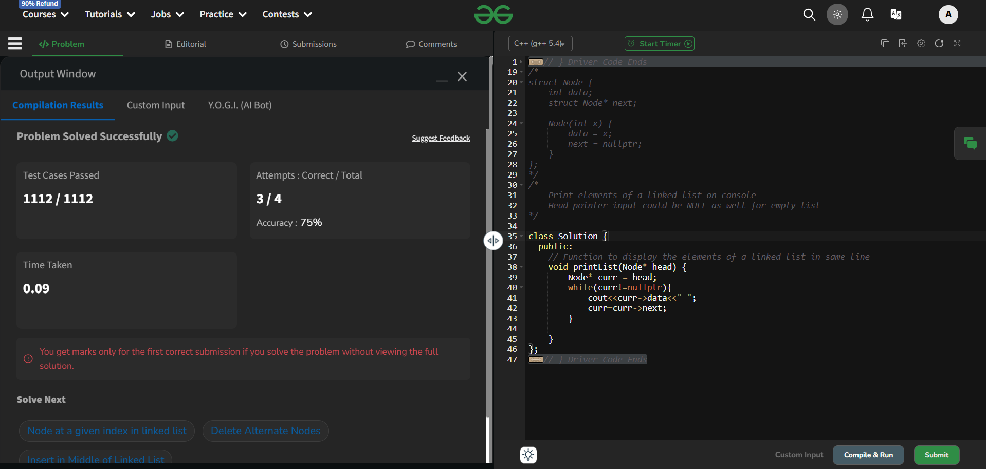

**Q2.** [**Remove duplicates from a sorted list**](https://leetcode.com/problems/remove-duplicates-from-sorted-list/description/)**:**

**CODE:**

class Solution {

public:

    ListNode* deleteDuplicates(ListNode* head) {

        ListNode* current = head;

        while (current && current->next) {

            if (current->val == current->next->val) {

                ListNode* temp = current->next;

                current->next = current->next->next;

                delete temp;

            } else {

                current = current->next;

            }}

        return head;

    }

};

**SCREENSHOT:**

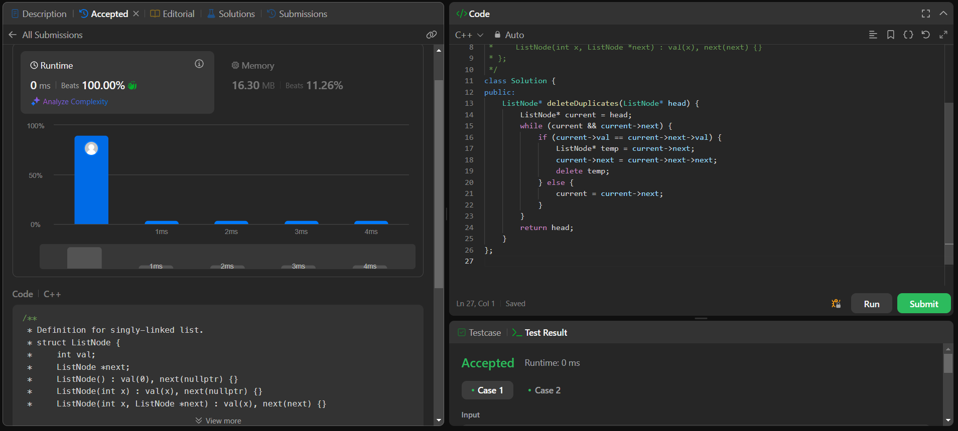

**Q3.Reverse a linked list:**

**CODE:**

class Solution {

public:

    ListNode* reverseList(ListNode* head) {

        ListNode *curr=head,*prev=nullptr,*next;

        while(curr!=nullptr){

            next=curr->next;

            curr->next=prev ;

            prev=curr;

            curr=next;

        }

        return prev;

    }

};

**SCREENSHOT:**

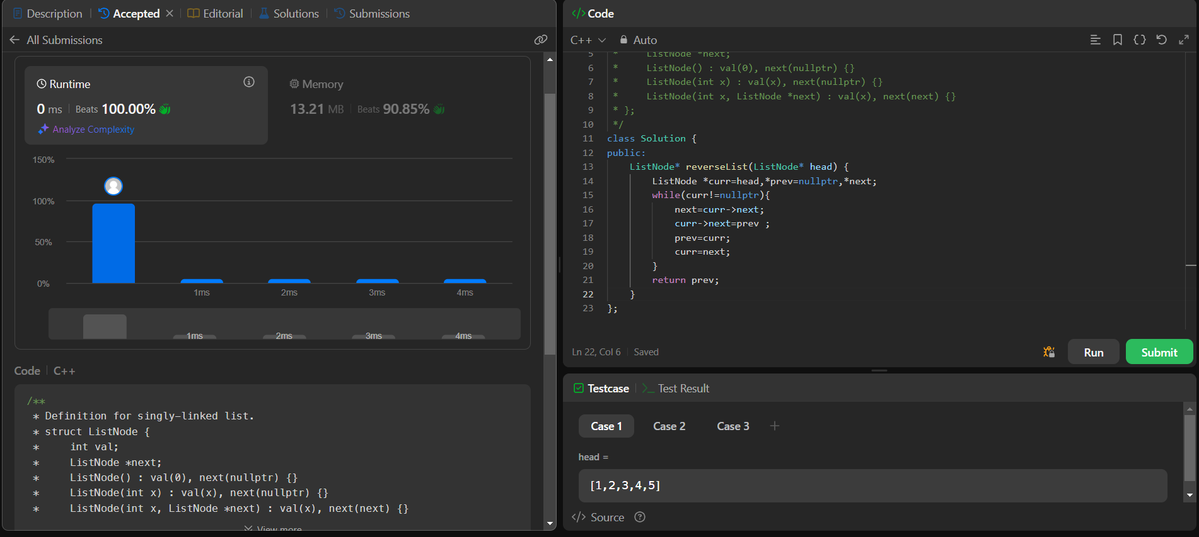

**Q4.** [**Delete middle node of a list**](https://leetcode.com/problems/delete-the-middle-node-of-a-linked-list/description/)**:**

**CODE:**

class Solution {

public:

ListNode* deleteMiddle(ListNode* head) {

if (!head || !head->next) return nullptr;

ListNode* slow = head;

ListNode* fast = head;

ListNode* prev = nullptr;

while (fast && fast->next) {

prev = slow;

slow = slow->next;

fast = fast->next->next;

}

prev->next = slow->next;

delete slow;

return head;

}

};

**SCREENSHOT:**

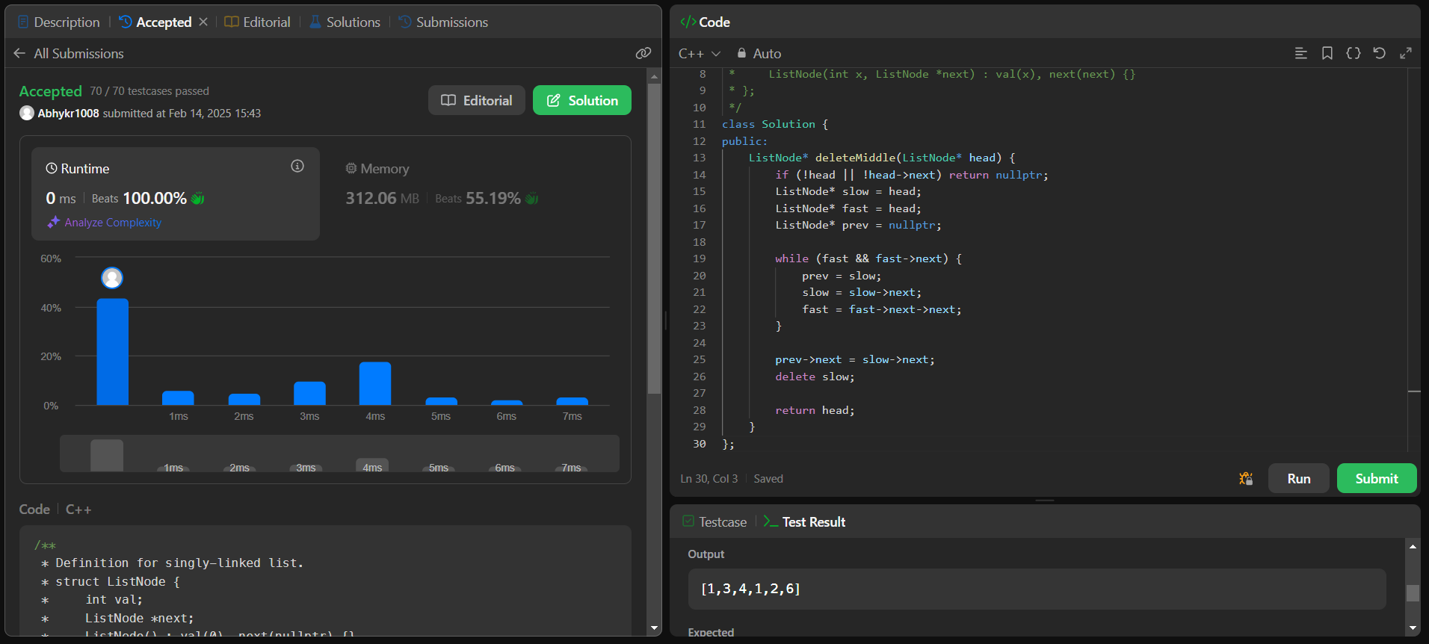

**Q5.** [**Merge two sorted linked lists**](https://leetcode.com/problems/merge-two-sorted-lists/description/)**:**

**CODE:**

class Solution {

public:

    ListNode* mergeTwoLists(ListNode* l1, ListNode* l2) {

        if (!l1) return l2;

        if (!l2) return l1;

        if (l1->val < l2->val) {

            l1->next = mergeTwoLists(l1->next, l2);

            return l1;

        } else {

            l2->next = mergeTwoLists(l1, l2->next);

            return l2;

        }

    }

};

**SCREENSHOT:**

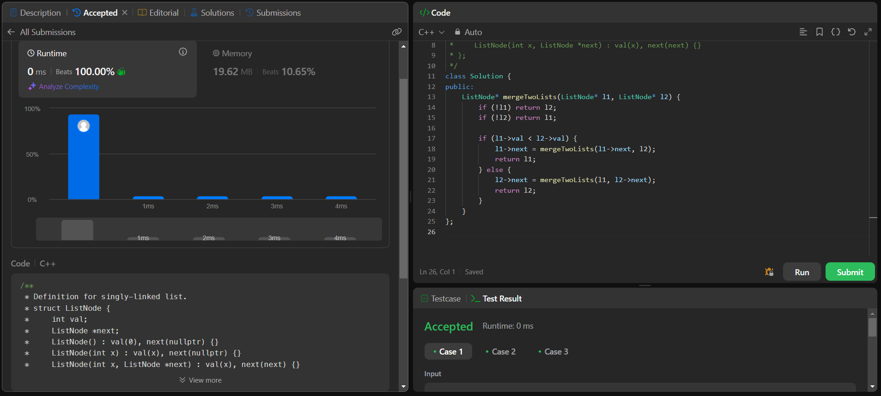

**Q6.** [**Remove duplicates from sorted lists 2**](https://leetcode.com/problems/remove-duplicates-from-sorted-list-ii/description/)**:**

**CODE:**

class Solution {

public:

    ListNode* deleteDuplicates(ListNode* head) {

        ListNode* temp = new ListNode(0);

        temp->next = head;

        ListNode* prev = temp;

        while (head) {

            bool duplicate = false;

            while (head->next && head->val == head->next->val) {

                duplicate = true;

                head = head->next;

            }

            if (duplicate) {

                prev->next = head->next;

            } else {

                prev = prev->next;  }

            head = head->next;}

        return temp->next;}

};

**SCREENSHOT:** 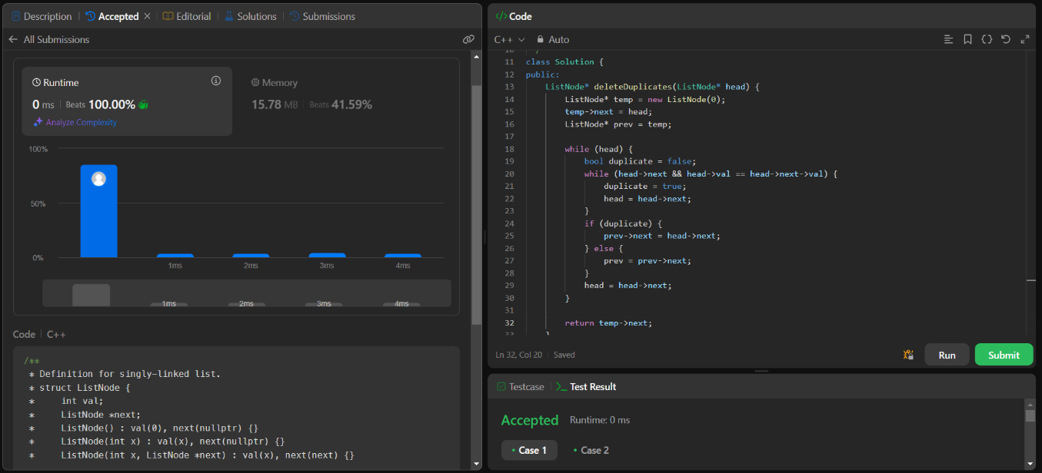

**Q7.** [**Detect a cycle in a linked list**](https://leetcode.com/problems/linked-list-cycle/description/)**:**

**CODE:**

class Solution {

public:

    bool hasCycle(ListNode *head) {

        ListNode *fast=head,*slow=head;

        while(slow && fast && fast->next){

            slow=slow->next;

            fast=fast->next->next;

            if(slow==fast){

                return true;

            }

}

            return false;

    }

};

**SCREENSHOT:**

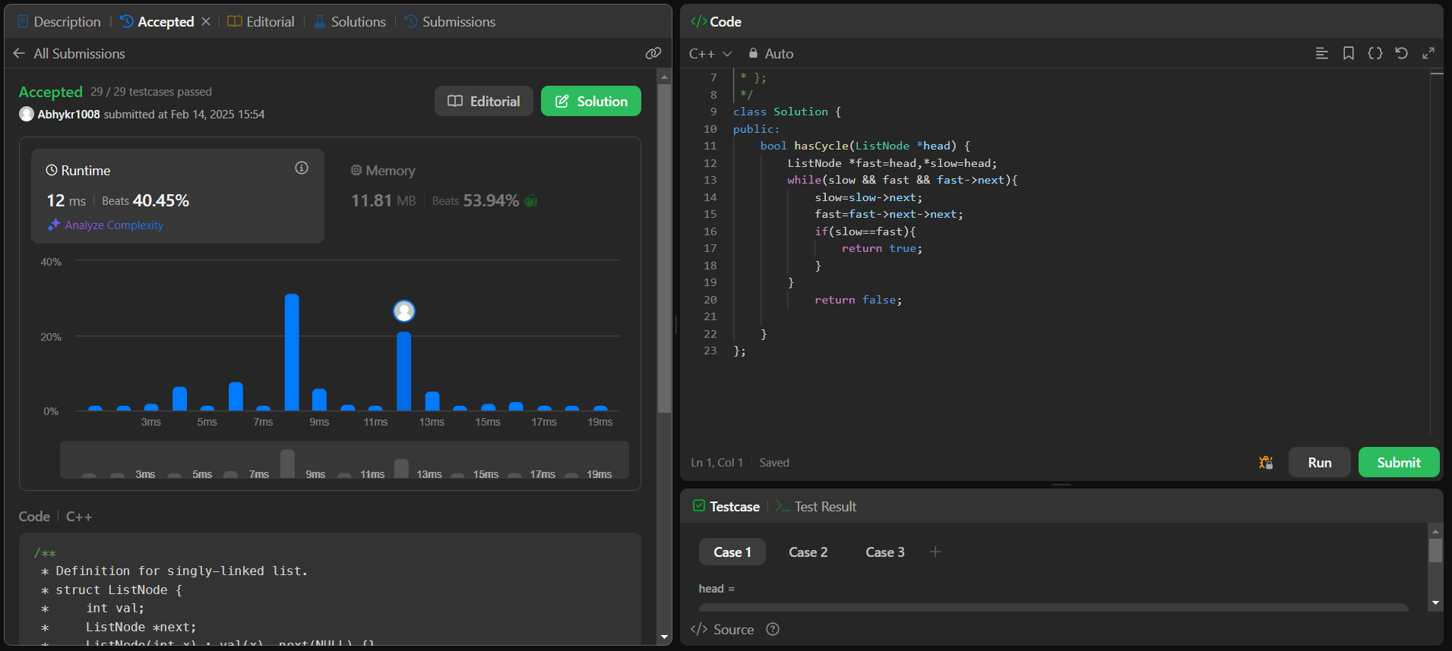

**Q8.** [**Reverse linked list 2**](https://leetcode.com/problems/reverse-linked-list-ii/description/)**:**

**CODE:**

class Solution {

public:

    ListNode* reverseBetween(ListNode* head, int left, int right) {

        if (!head || left == right) return head;

        ListNode* temp = new ListNode(0);

        temp->next = head;

        ListNode* prev = temp;

        for (int i = 1; i < left; i++) {

            prev = prev->next; }

        ListNode* curr = prev->next;

        ListNode* next = nullptr;

        for (int i = 0; i < right - left; i++) {

            next = curr->next;

            curr->next = next->next;

            next->next = prev->next;

            prev->next = next;   }

        return temp->next; }

};

**SCREENSHOT:** 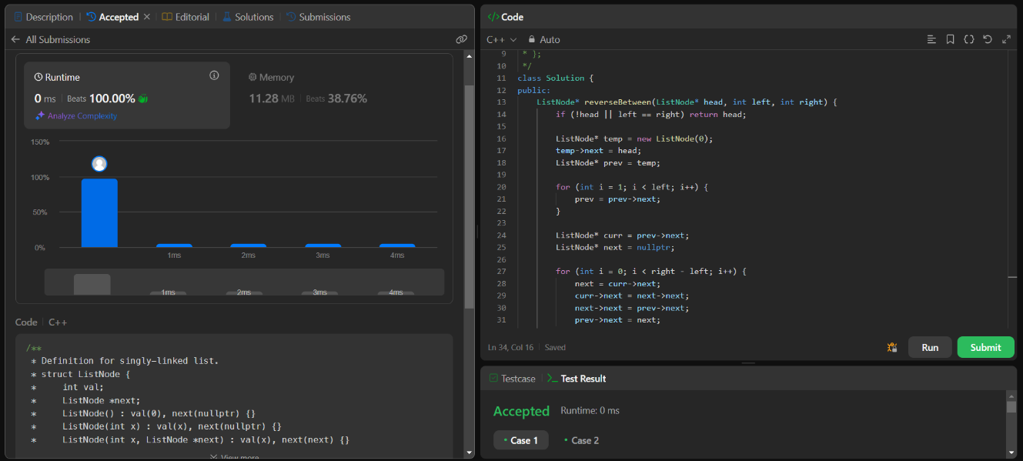

**Q9.** [**rotate a list**](https://leetcode.com/problems/rotate-list/description/)**:**

**CODE:**

class Solution {

public:

    ListNode* rotateRight(ListNode* head, int k) {

        if (!head || k == 0) return head;

        int length = 1;

        ListNode* tail = head;

        while (tail->next) {

            tail = tail->next;

            length++;    }

        k = k % length;

        if (k == 0) return head;

        tail->next = head;

        ListNode* newTail = head;

        for (int i = 0; i < length - k - 1; i++) {

            newTail = newTail->next; }

        head = newTail->next;

        newTail->next = nullptr;

        return head; }

};

**SCREENSHOT:** 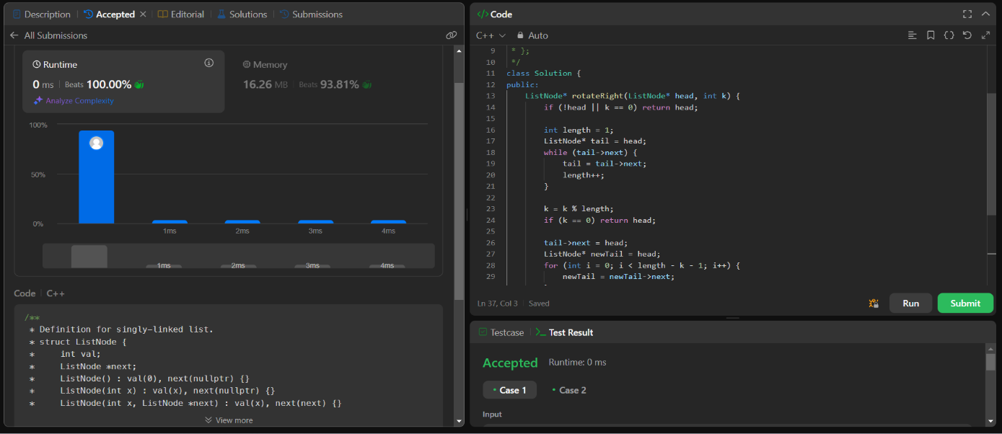

**Q10.** [**Sort List**](https://leetcode.com/problems/sort-list/description/)**:**

**CODE:**

class Solution {

public:

    ListNode* merge(ListNode* left, ListNode* right) {

        if (!left) return right;

        if (!right) return left;

        ListNode* dummy = new ListNode(0);

        ListNode* temp = dummy;

        while (left && right) {

            if (left->val < right->val) {

                temp->next = left;

                left = left->next;

            } else {

                temp->next = right;

                right = right->next;

            }

            temp = temp->next;

        }

        if (left) temp->next = left;

        if (right) temp->next = right;

        return dummy->next;

    }

    ListNode* sortList(ListNode* head) {

        if (!head || !head->next) return head;

        ListNode* slow = head;

        ListNode* fast = head->next;

        while (fast && fast->next) {

            slow = slow->next;

            fast = fast->next->next;

        }

        ListNode* mid = slow->next;

        slow->next = nullptr;

        ListNode* left = sortList(head);

        ListNode* right = sortList(mid);

        return merge(left, right);

    }

};

**SCREENSHOT:**

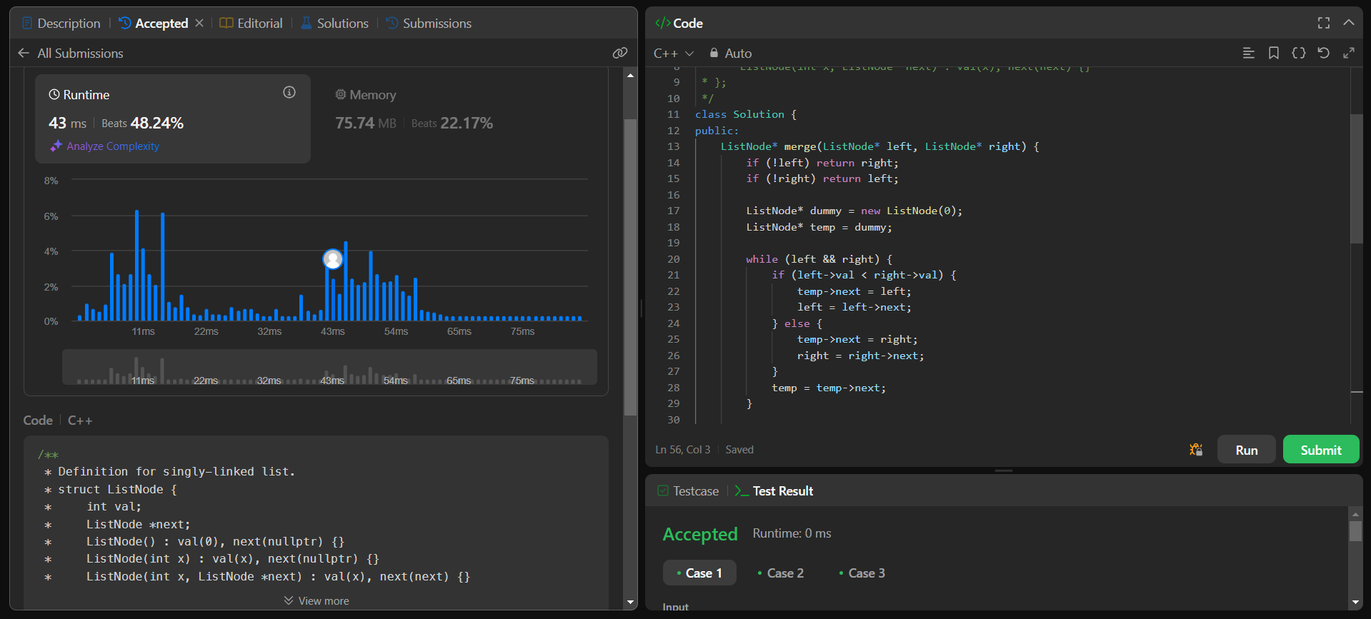

**Q11.** [**Detect a cycle in a linked list 2**](https://leetcode.com/problems/linked-list-cycle-ii/description/)**:**

**CODE:**

class Solution {

public:

    ListNode* detectCycle(ListNode* head) {

        if (!head || !head->next) return nullptr;

        ListNode* slow = head;

        ListNode* fast = head;

        while (fast && fast->next) {

            slow = slow->next;

            fast = fast->next->next;

            if (slow == fast) {

                slow = head;

                while (slow != fast) {

                    slow = slow->next;

                    fast = fast->next; }

                return slow;

            }  }

return nullptr; }

};

**SCREENSHOT:**

